Exploratory Data Analysis (EDA) Report For AI-Based Crime Pattern And Predictive Policing
By Niyanta Parihar & Utkarsh Singh
- Objective
The objective of this Exploratory Data Analysis (EDA) is to understand the structure and characteristics of the India Crime Master Dataset and the 2011 Census Dataset, identify crime patterns and trends, examine temporal and spatial distributions of crime incidents, analyze relationships among variables, and generate insights that can support feature selection and future machine learning-based crime prediction models.
- Data Overview
- Dataset Name: India Crime Master Dataset, 2011 Census Dataset
- Total Records: 22,243
- Total Features: 43
- Data Types: Numerical and Categorical
- Coverage: Crime-related records collected from multiple districts across India
- Temporal Analysis
Temporal Analysis was performed to examine how crime incidents vary across different time periods. The analysis focuses on hourly crime frequency, weekday versus weekend crime distribution, and monthly crime trends. Understanding temporal patterns helps identify peak crime periods and provides valuable insights for crime forecasting and predictive policing applications.
3.1 Crime Frequency by Hour
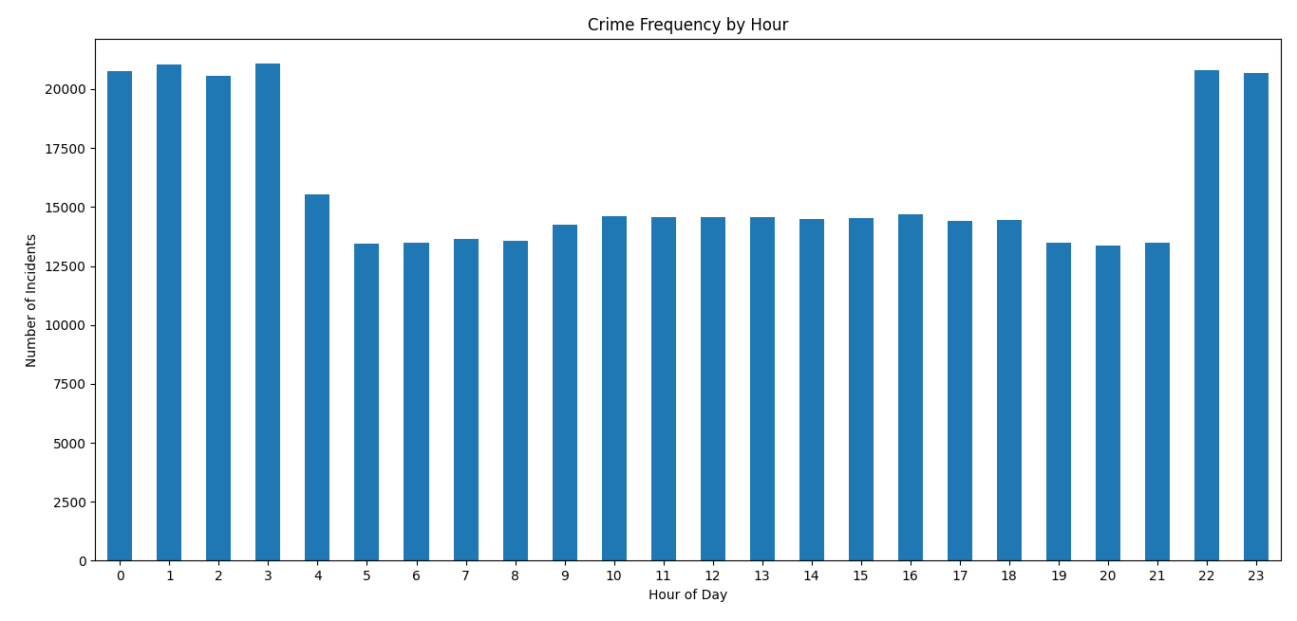
Figure 1: Crime Frequency by Hour
Observation
The highest crime frequencies were recorded during late-night and early-morning hours, particularly at 3 AM (21,086 incidents), 1 AM (21,060 incidents), 10 PM (20,800 incidents), and 12 AM (20,775 incidents). Lower crime frequencies were observed during early morning and evening hours, including 5 AM, 6 AM, and 8 PM.
Interpretation
Crime occurrence appears to vary across different hours of the day. The concentration of incidents during late-night hours suggests that time may influence crime patterns and reporting behavior.
Conclusion
Time of occurrence is an important temporal factor and should be considered during crime pattern analysis and predictive modeling.
3.2 Weekday vs Weekend Analysis
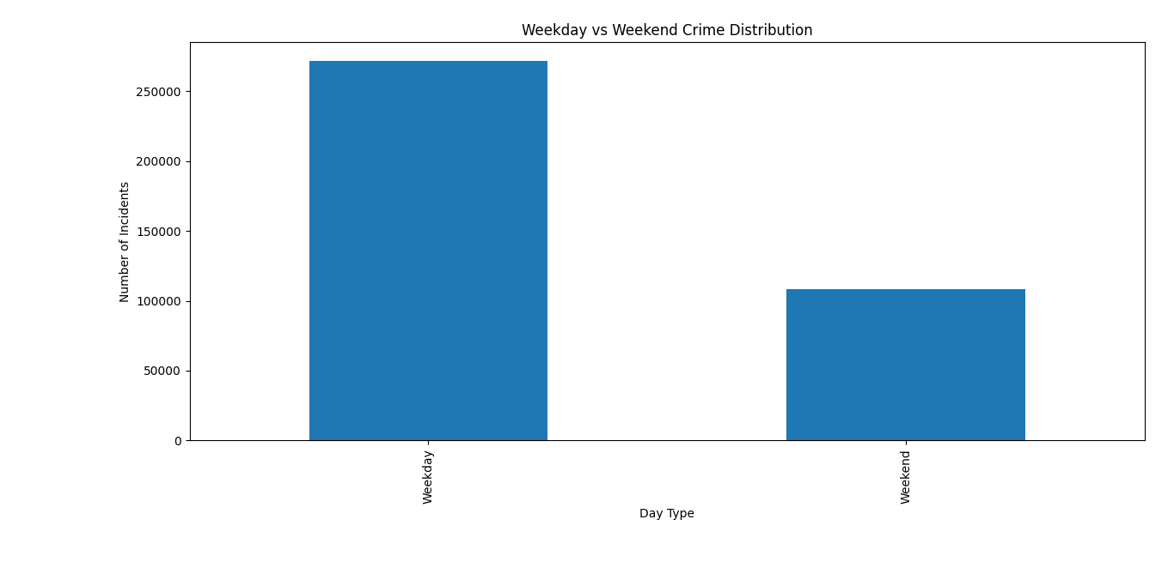
Figure 2: Weekday vs Weekend Crime Distribution
Observation
Weekdays accounted for 271,792 incidents, while weekends accounted for 108,353 incidents. However, when adjusted for the number of days, crime occurrence remained relatively consistent across weekdays and weekends.
Interpretation
Crime activity does not appear to be strongly concentrated on specific days of the week. The relatively uniform distribution suggests that crime occurrence is influenced by factors beyond simple weekday–weekend differences.
Conclusion
Day type alone may not be a strong predictor of crime occurrence, although it can still contribute useful contextual information for predictive models.
3.3 Seasonal Crime Trends
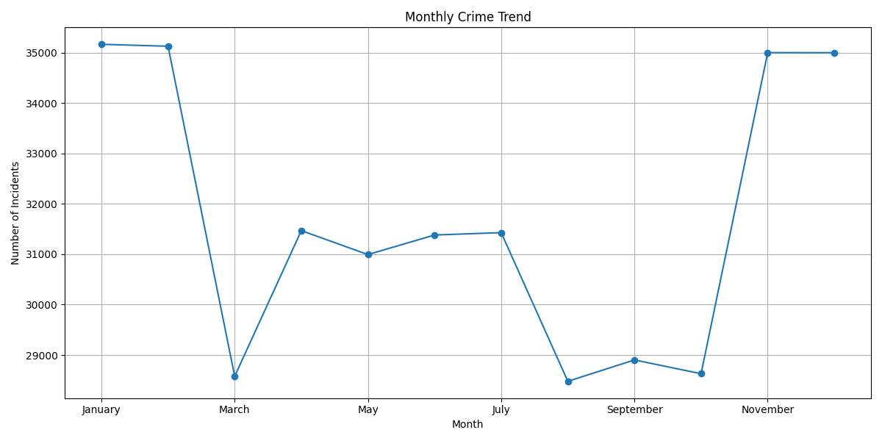
Figure 3: Monthly Crime Trend
Observation
Higher crime frequencies were observed during January (35,165 incidents), February (35,126 incidents), November (35,000 incidents), and December (34,998 incidents). Lower crime frequencies were recorded during August (28,478 incidents), March (28,577 incidents), October (28,629 incidents), and September (28,902 incidents).
Interpretation
The variation in monthly crime frequencies indicates the presence of seasonal influences on crime occurrence. However, the variation is moderate rather than extreme.
Conclusion
Seasonal patterns exist within the dataset and month-based features may improve crime forecasting and trend analysis.
- Spatial Analysis
Spatial analysis was conducted to examine the geographical distribution of crime incidents across different districts and regions. The objective is to identify crime-prone locations and understand the spatial patterns of crime occurrence.
4.1 Crime Concentration by Location
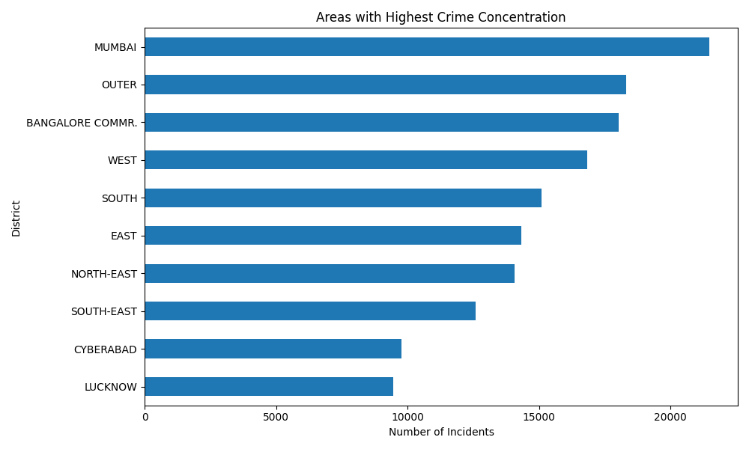
Figure 4: Areas with Highest Crime Concentration
Observation
Mumbai recorded the highest number of crime incidents (21,489), followed by Outer Delhi (18,322), Bangalore Commissionerate (18,023), and several other metropolitan districts.
Interpretation
Crime incidents are concentrated in major urban regions where population density, economic activity, and reporting rates are generally higher.
Conclusion
Geographical location plays an important role in crime occurrence and should be included as a key feature in predictive policing models.
4.2 Hotspot Region Analysis
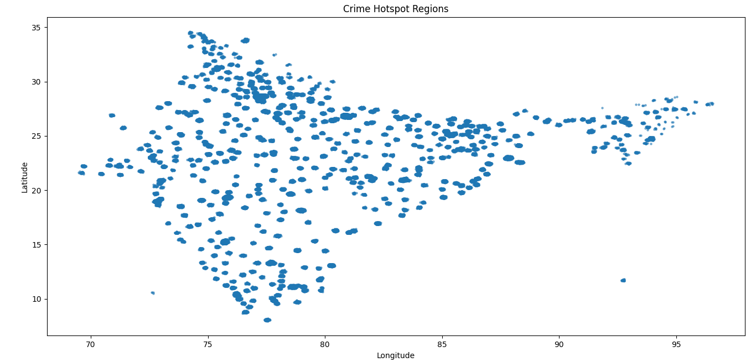
Figure 5: Crime Hotspot Regions
Observation
Crime records are geographically clustered around major urban and densely populated regions rather than being evenly distributed across all locations.
Interpretation
The clustering of incidents suggests that certain geographical areas experience higher crime concentrations than others.
Conclusion
Spatial features such as latitude, longitude, district, and state information are important for identifying crime hotspots and improving predictive performance.
- Crime-Type Analysis
Crime-type analysis was performed to identify the most common crime categories and study their trends over time. This analysis helps understand the distribution and evolution of different crime types within the dataset.
5.1 Most Common Crime Categories
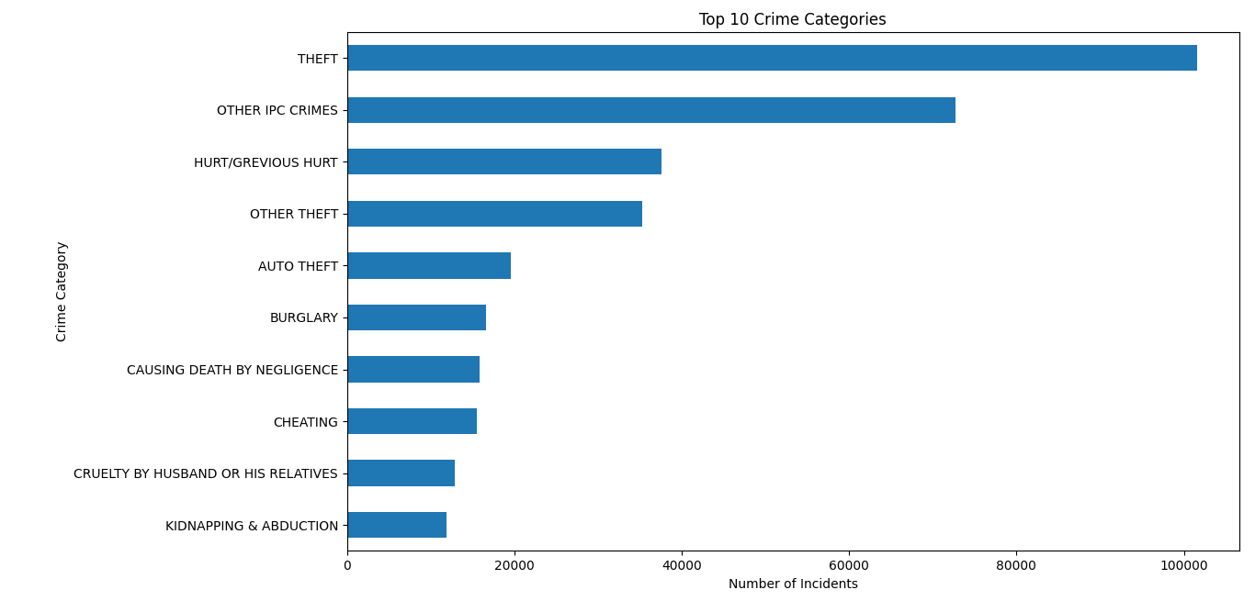
Figure 6: Most Common Crime Categories
Observation
Theft was the most common crime category with 101,557 incidents, followed by Other IPC Crimes (72,737 incidents) and Hurt/Grievous Hurt (37,522 incidents).
Interpretation
Property-related crimes account for a substantial proportion of reported incidents, indicating their significance within the overall crime distribution.
Conclusion
Crime category distribution is highly imbalanced, with theft-related crimes dominating the dataset. This should be considered during model development and evaluation.
5.2 Crime Trends Over Time
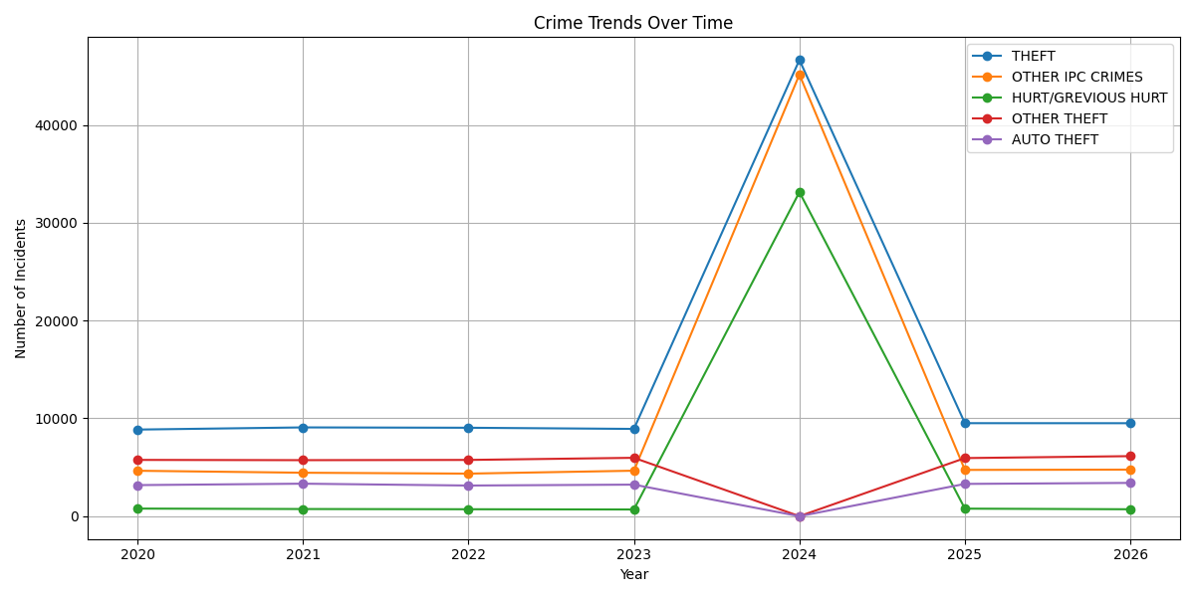
Figure 7: Crime Trends Over Time
Observation
Major crime categories such as Theft, Other IPC Crimes, and Hurt/Grievous Hurt remained among the most frequently reported crimes across the analyzed years. An unusual spike was observed in some categories during 2024.
Interpretation
The trend analysis indicates that crime patterns vary over time. However, certain anomalies observed in the data may reflect reporting changes, categorization differences, or dataset-specific inconsistencies.
Conclusion
Historical crime trends provide useful predictive information, but anomalies and inconsistencies should be carefully verified before drawing final conclusions or training machine learning models.
- Correlation Analysis
Correlation analysis was conducted to examine relationships among demographic and socio-economic variables. The objective is to identify potential associations that may be useful during feature selection and predictive modeling.
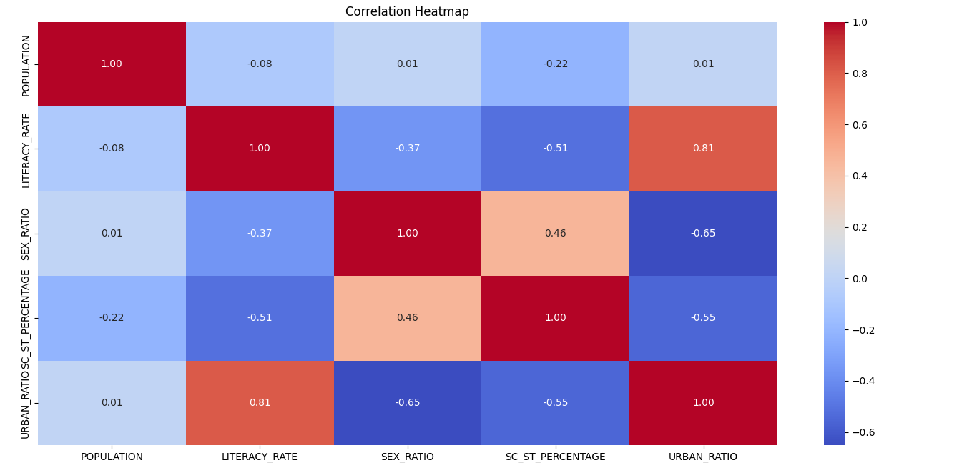
Figure 8: Correlation Heatmap
Observation
The correlation heatmap indicates a strong positive correlation between Literacy Rate and Urban Ratio (0.81). Moderate negative correlations were observed between Urban Ratio and Sex Ratio (-0.65), and between Urban Ratio and SC/ST Percentage (-0.55). Population exhibited weak correlations with most other variables, suggesting limited linear relationships.
Interpretation
The results suggest that districts with higher levels of urbanization generally tend to have higher literacy rates. Certain demographic variables also appear to vary with urbanization levels. The weak correlations involving population indicate that population alone does not strongly explain the variation in other demographic features.
Conclusion
Several demographic and socio-economic variables exhibit meaningful relationships with one another. These relationships can provide valuable contextual information during feature selection and may contribute to improving the performance of machine learning models used for crime prediction and pattern analysis.
- Key Insights
- Crime frequency varies across different hours of the day, with higher incident counts observed during certain late-night and early-morning hours.
- Crime occurrence remains relatively consistent across weekdays and weekends when adjusted for the number of days.
- Seasonal variations are present, with higher crime frequencies observed during January, February, November, and December.
- Crime incidents are concentrated in major urban districts such as Mumbai, Bangalore Commissionerate, and several districts of Delhi.
- Geographical clustering suggests the presence of potential crime hotspot regions.
- Theft was identified as the most common crime category, followed by Other IPC Crimes and Hurt/Grievous Hurt.
- Historical crime trends reveal variations across crime categories and indicate the importance of temporal information for predictive analysis.
- Correlation analysis revealed strong relationships among certain demographic and socio-economic variables, particularly between Literacy Rate and Urban Ratio.
- Conclusion
The Exploratory Data Analysis (EDA) provided valuable insights into the temporal, spatial, crime-type, and demographic characteristics of the dataset. The analysis revealed variations in crime occurrence across different hours, months, locations, and crime categories. Spatial analysis identified geographical clustering of crime incidents, while crime-type analysis highlighted the dominance of theft-related offenses. Correlation analysis further revealed meaningful relationships among demographic and socio-economic variables. Overall, the findings help improve understanding of crime patterns and provide a strong foundation for feature selection, machine learning model development, and future predictive policing applications.

